Week Ending: | DAY: |  |  |  | Subject: Mathematics
Duration: 60mins per lesson |  |  |  |  | Strand: Data
Class: B4 | Class Size: |  |  |  | Sub Strand: Data Collection And Organization
Content Standard:  B4.4.1.1 Demonstrate an understanding of many-to-one correspondence in displaying, and reading or interpreting, graphs |  |  | Indicator:  B4.4.1.2.1 -2 Identify common features of graphs and use understanding of many-to-one correspondence to solve simple problems |  |  | Lesson:  1 OF 1
Performance Indicator:  Learners can Identify common features of graphs and use understanding of many-to-one correspondence to solve simple problems |  |  |  | Core Competencies:  Problem Solving skills; Critical Thinking; Justification of Ideas; Collaborative Learning; Personal
Teaching/ Learning Resources |  | Class registers, school based assessment
References: Mathematics Curriculum Pg. 53
DAYS | PHASE 1: STARTER | PHASE 2: MAIN | PHASE 3: REFLECTION
Monday | Review learners understanding in the previous lesson using questions and answers  Engage learners to play games and sing songs to begin the lesson. | Examine such features as title, vertical axis and label, horizontal axis and label, key or legend.  Give students data presented in a table to draw bar graph complete with title, labelled axes, key. The table show amount of rainfall recorded in Kumasi in the half of the year. | Give learners task to complete whiles you go round to guide those who don’t understand.  Give remedial learning to those who special help.
Tuesday | Let learners solve this  Using only addition, how can you use eight eights to get the number 1000?  Answer: 888+88+8+8+8 | Give pupils data on energy usage by households in a community over a period (e.g. six months) presented in tables for them to draw bar graph complete with title, labelled axes, key. Ask questions for pupils to read and interpret graphs. | Give learners task to complete whiles you go round to guide those who don’t understand.  Give remedial learning to those who special help.
Wednesday | Engage learners to sing the song  WE CAN COUNT  We class four  We can count  We count 1,2,3,4,5  We count 6,7,8,9,10  We class four can count very well. | Give learners several graphs that have used many-to-one correspondence in displaying the same data.  For example, the graph below on the number of pupils treated for malaria in a school.  Ask questions for children to read and interpret graphs.  i) How many pupils were treated for malaria in the hospital in April?  ii) How many pupils were treated for malaria in the hospital in May and June? | Give learners task to complete whiles you go round to guide those who don’t understand.  Give remedial learning to those who special help.
Thursday | Let learners solve this  Using only addition, how can you use eight eights to get the number 1000?  Answer: 888+88+8+8+8 | Give learners several graphs that have used many-to-one correspondence in displaying the same data.  For example, a graph on the number of pupils admitted into school in 2019.  Ask questions for children to read and interpret graphs | Give learners task to complete whiles you go round to guide those who don’t understand.  Give remedial learning to those who special help.
Friday | Can you put the digits 1 to 11 in the circles do that every line has the same total?  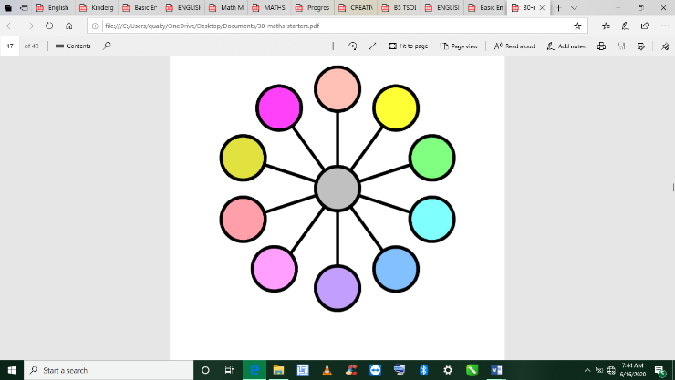 | Give learners several graphs that have used many-to-one correspondence in displaying the same data.  For example, a graph on the number of pupils and the days they were born.  Ask questions for children to read and interpret graphs | Give learners task to complete whiles you go round to guide those who don’t understand.  Give remedial learning to those who special help.

